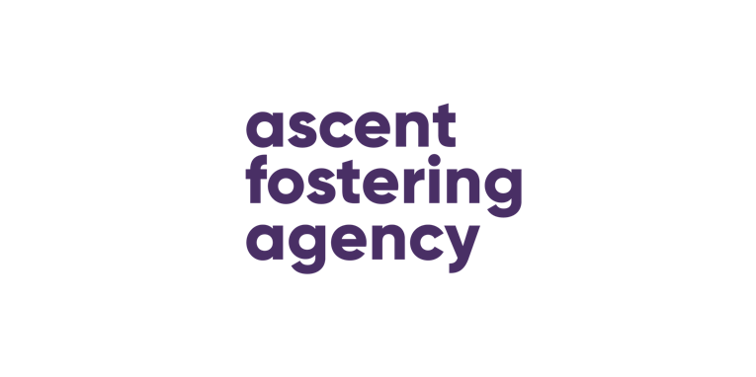

Ascent Fostering Agency
Statement of Purpose 2019

“Our values make us different”

CONTENTS

Section 1 | Aims & Objectives
Section 2 | Status & Constitution
Section 3 | Management structure
Section 4 | Fostering Panel
Section 5 | Insurance
Section 6 | Recruiting, approving, training and supporting foster carers
Section 7 | Service provision
Section 8 | External relationships- Reaching Higher
Section 9 | Number of foster carers
Section 10 | Number of fostered children/young people
Section 11 | Staffing
Section 13 | Complaints & Outcomes
Section 14 | Clinical governance

INTRODUCTION
This document sets out the statement of purpose and function of the Ascent Fostering Agency Ltd (AFA) as an independent fostering agency.
The Ascent fostering Statement of Purpose provides a range of information which is intended for a wide audience:
- Looked After Children
- Parents of Children
- Foster carers and prospective foster carers
- Ascent Fostering Staff
- Local authorities, health and social care trusts, who place, or are considering placing with the agency
- Ofsted
- General public
The Ascent Fostering statement of purpose meets:

- The Care Standards Act 2000
- The Fostering Services Regulations 2011
- The National Minimum Standards for Fostering 2011
- The Children Act 1989
- Human rights Act 1998
- Data Protection Act 1998

The Statement of Purpose will be reviewed regularly, or at least annually by the Ascent Fostering Agency Management Team.

VALUES
Ascent fostering Agency believes its core values sets its apart from many other providers, our values are:
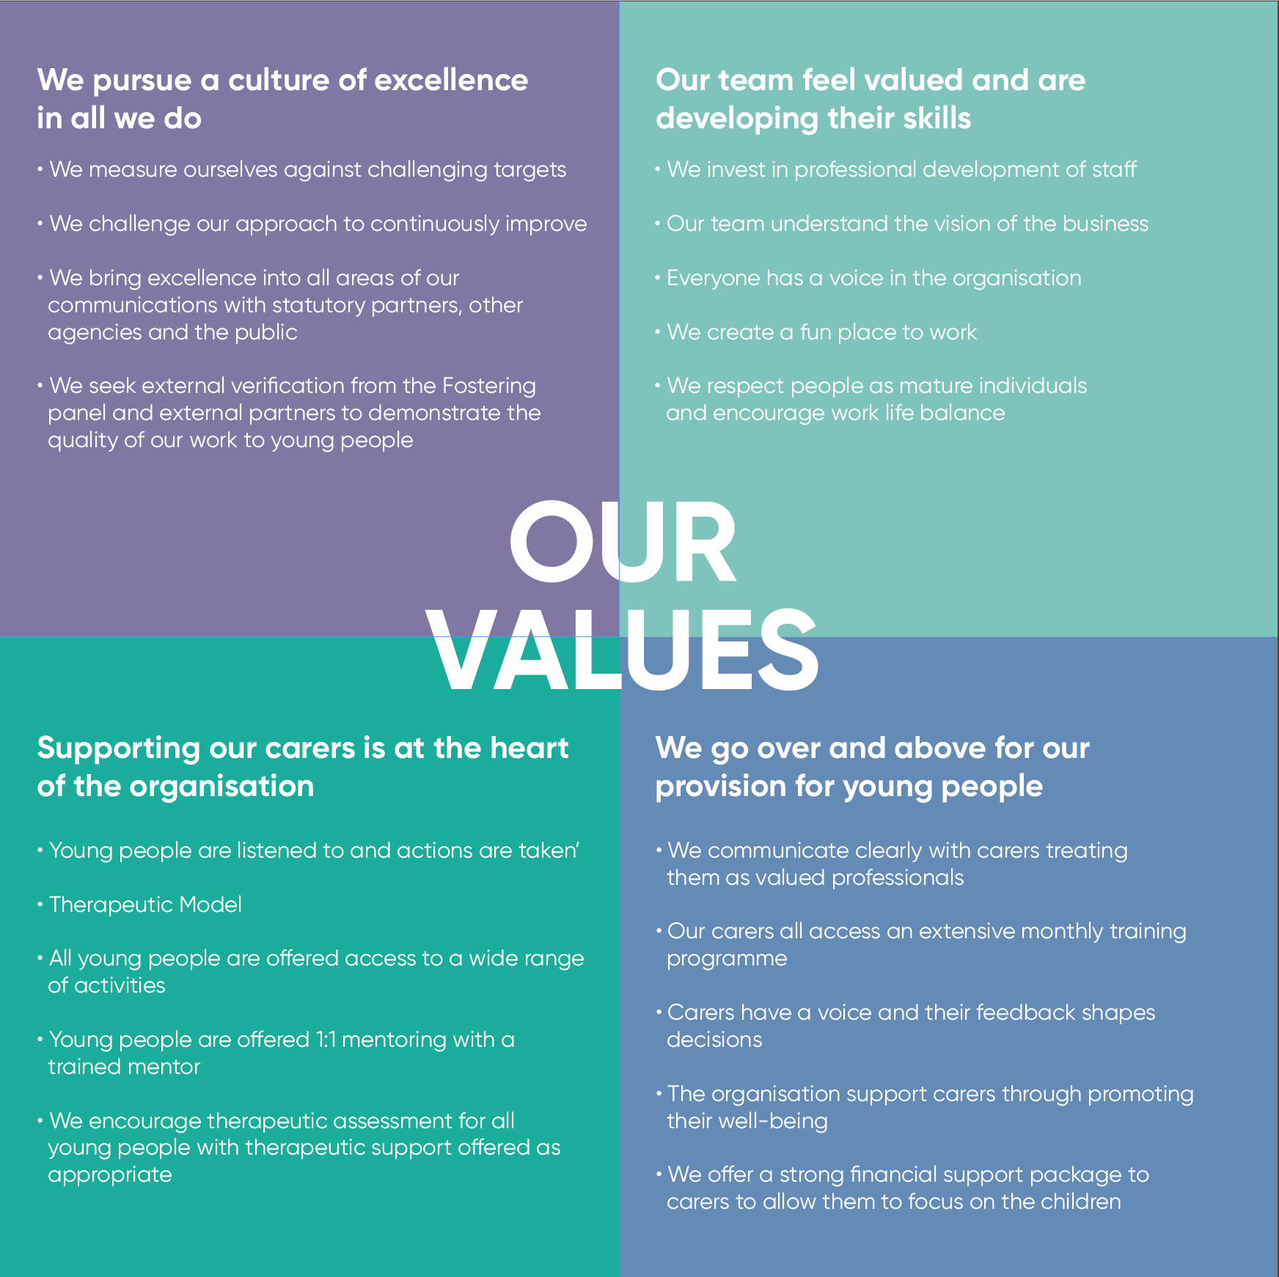
- WE GO OVER & ABOVE IN OUR PROVISION FOR YOUNG PEOPLE
- OUR TEAM FEEL VALUED AND ARE DEVELOPING THEIR SKILLS
- SUPPORTING OUR CARERS IS AT THE HEART OF THE ORGANISATION
- WE PURSUE A CULTURE OF EXECELLENCE IN ALL WE DO
Ascent fostering challenges its self to live its values though its engagement with young people, its foster carers and staff. We reaffirm this with our commitment to help support young people recover from the impact of trauma.
AIMS & OBJECTIVES
Ascent Fostering is independent fostering agency, that has a therapeutic approach that supports children and young people who require foster care. The agency works with children and young people who have a range of complex care needs and offers bespoke care and support packages within a family setting. This is achieved by supporting families who care for the young people in a creative way.
Our ethos is to meet children at their ‘map of the world’. Our foster carers intentionally parent children on their journey to recovery. Through intensive support and mentoring. Our aim is to build relationships with young people that are safe and supportive. Ascent foster carers engage in additional therapeutic training to help them understands the needs of children and the presenting behaviour they face.
We engage with young people in a number of ways, include mentoring and personal development through our partner organisation Reaching Higher, who support young people through mentoring and access to creative arts, sport and music.

Ascent Fostering will provide:
- High quality care for children and young people who are looked after in foster care.
- A commitment to supporting each child/young person as an individual with unique needs.
- 24 hour support for foster carers and children/young people.
- A community-based service at a local level.
- A commitment to the recruitment of foster carers from diverse backgrounds so that Ascent fostering can offer appropriate placements for all children and young people.
- A consideration of ethnicity, gender, sexuality and disability of fostered children and young people when making placement and matching decisions.
- A commitment to the ongoing learning and development of foster carers, that supports them in achieving the highest standards of foster care.
- A commitment to developing the skills to meet the most complex needs of children and young people.
- A commitment to the ongoing development of staff.
- Placements that are safe, nurturing and protective, where children and young people will be treated with respect and dignity.
- Children and young people will be encouraged, nurtured and supported in a family setting where shared values are upheld and their individual needs and differences respected.
- An ongoing dialogue with the children and young people we care for, along with carers and the local authority about how we can improve our services.

STATUS & CONDITIONS
Ascent Fostering, an independent fostering provider (IFP), is a private limited company registered under the Companies Act 1985 (Company Number 08252409).
In accordance with the Companies Acts 1985 and 1989, Ascent Fostering Agency Ltd has produced a Memorandum of Association and Articles of Association. Copies of the Memorandum of Association and Incorporation certificate have been made available to Ofsted, which is the independent, non-governmental regulatory authority for independent fostering agencies throughout England.
MANAGEMENT TEAM
Ascent Fostering has a management team comprising of:

- Mark Pomell, Managing Director (Registered Manager)
Mark is a qualified social worker and has a Masters in Management, he has over 30 years of experience within social care. Over the last 20 years Mark has worked at a senior management level in both the statutory and the private sector.

Mark Hobbs, Commercial Director (Registered Individual)
Qualifying as a Chartered Accountant with Ernst & Young in 2002, Mark has over a decade of experience in senior financial management including senior roles at FTSE 100 companies. Mark has also spent over 17 years developing and leading work with young people. This culminated in 2010 with him founding youth charity Reaching Higher which has quickly developed into a thriving organisation delivering outstanding results in the community. Mark combines his passion for seeing young people thrive with his management experience to good affect at Ascent Fostering.

- Zoya Byelovolova, Team Manager
Zoya has extensive and varied experiences of social work practice. Zoya has managed teams and completed independent reviews and consultancy. She has work In the statutory sector and independently
Zoys is passionate about children’s welfare and is interested in the impact of attachment and trauma, as well as the benefits of therapeutic fostering.
The Ascent Fostering Management team is responsible for:
- The organisation's vision and mission
- Quality Standards & Management Systems
- Fulfilling statutory duties and responsibilities
- The values to be promoted throughout Ascent Fostering
- The strategic direction and goals of the organisation
- The organisation's policies
- The annual business & development plan
- Major financial expenditure decisions
The organisation has separate documents which detail the qualifications and experience of staff. These documents are available on request.
STAFFING
- Ascent Fostering has a board of 2 Executive Directors, Mark Hobbs and Mark Pomell.
- In post is a Team Manager FT, FT Practice Manager, 3 FT supervising Social worker, 0.5 supervising social worker 1 FT administrator, 1 PT administrator, 2 FT Therapeutic support workers
- 24 hrs of contracted therapeutic hours per week, (therapeutic child care practitioner) 0.6
- Ascent contracts additional mentoring hours through Reaching Higher Charity.
- Managers and staff members receive supervision and appraisal in accordance to their role and responsibilities.
- Qualified sessional social workers are commissioned to undertake Coram BAAF Form F assessments and present them to panel. Formal qualifications and CVs of all sessional social workers are available on request.
In relation to all staff, it is expected that:
- Qualified Supervising social workers are registered with the Health & Social Care Professionals Council.
- All staff are covered by appropriate professional indemnity insurance and all have job descriptions, contracts of employment and annual appraisal and are appropriately DBS.

Role and Responsibilities

Team Manager are responsible for the supervision and management of Supervising Social Workers. In ascent fostering the TM is responsible for the day to day function of the organisation. Quality assurance function is an integral part of this role and they ensure that ascent is compliant and will oversee monitoring.

Supervising Social Workers (SSWs)
The SSWs have responsibility for the assessment, support, supervision and annual review of foster carers. In addition, they work in close partnership with the Looked After Children’s Social Worker and will attend Looked After Reviews and Personal Education Plan (PEP) meetings with the foster carer to ensure the very best outcomes are achieved for children placed with our carers. SSWs are responsible for monitoring the continuous professional development and training of foster carers. They ensure that all foster carers complete the Training, Support and Development Standards (TSDs) and maintain an ongoing portfolio; working closely with the Learning and Development Team to facilitate this. In addition, SSWs co-ordinate and deliver support groups for foster carers and provide the frontline delivery of Out of Hours Services to carers. Support Workers Support Workers provide specific support services to both foster carers and children and young people, and have experience of working with children in a variety of settings.

Ascent SSW are DDP trained Dyadic Developmental Practice and (SAI) Sensory Attachment intervention training. Further Ascent has its own therapeutic programme that all workers complete. Our commitment to this this level of professional training means we are able to offer therapeutic solutions to children with the most complex needs. Our SSW are to guide foster carers
Therapeutic Fostering support worker
At Ascent fostering our therapeutic support workers who support placement by engaging with young people , to act as mentors, advocates and to help young people find practical ways of solving the challenge they face in their lives. Input is time-limited and solution focussed to enable those supported to achieve personal growth and development.
FOSTERING PANEL
Ascent Fostering has its own fostering panel, comprising of members with relevant child care and statutory social work experience. Including a care leaver, paediatric nurse, social workers, teachers and a connections worker. The panel chair and minute takers have undertaken Corum/BAAF training.
Ascent Fostering panel and staff members are recruited in accordance with “safer recruitment” guidelines.
Ascent Fostering must consult the Fostering Panel in considering the approval of foster carers, and in drawing up and reviewing fostering arrangements. The Panel must consider:
- Each application for approval as a foster carer and recommend whether or not a person is suitable to act as a foster carer
- Where it recommends approval of an applicant, the terms on which approval is to be given.
- Whether or not to recommend a foster carer’s ongoing suitability to continue acting as a foster carer and whether or not their terms of approval remain appropriate:
(i) On the first review within 12 months of initial approval
(ii) On the occasion of any other review when requested to do so by Ascent Fostering.
- A foster carer’s suitability to continue acting as a foster carer following investigations into allegations or serious concerns about a foster carer’s standards of care, and to make recommendation on further support and training needed, in keeping Ascent Fostering’s Managing Serious Concerns policy.
In addition, the Panel also advises on the reviewing procedures and monitors this effectiveness. They also oversee the conduct of assessments and make recommendations on such matters or cases as the fostering service may refer to it.
The Ascent Fostering Panel can only make recommendations as it is the Agency Decision Maker who makes a formal decision. This process takes seven working days.
It is Ascent Fostering policy:
- That all foster carers attend panel for their approval and first annual review.
- All foster carers subsequently return for their 3 yearly review.

RECRUITING, APPROVING, TRAINING, SUPPORTING AND REVIEWING FOSTER CARERS
ASSESSMENT AND APPROVALS
Ascent fostering robustly assess the suitability of individuals or families to foster we seek people who have a good enough understanding of children in the care system. They must demonstrate a wiliness to learn and develop new skills if they wish to foster for Ascent.
In general the assessment process takes up-to 4 months.
- Initial enquiry - On receiving an enquiry from a potential foster carer(s), Ascent Fostering requests basic information to satisfy that the enquirer is capable of fulfilling the organisation's requirements to provide safe and nurturing families. If satisfied, Ascent Fostering literature and an application pack is forwarded to the enquirer.
- Initial assessment the management team will consider the information, if appropriate, arrange an initial visit. The initial visit report is presented to the recruitment manager team and the decision whether or not to proceed is made.
- Application to Foster - (stage 1) The potential foster carer(s) complete(s) an application form, giving detailed information about them and their family and gives consent for Ascent Fostering to complete necessary checks and enquiries to ascertain their suitability to foster. Full Assessment - Stage 2. If the decision is made to proceed, a qualified social worker carries out a comprehensive Form F1 assessment. He/she visits the applicant(s) home, generally on 6-8 occasions, to meet and collect information about all members of the household and the applicant’s experience and skills in relation to fostering.
- Preparation training (Skills to Foster) is provided which covers the responsibilities of being a foster carer and working with Ascent Fostering. All prospective foster carers must attend this training prior to their approval.
- Statutory checks form part of the assessment (stage1/2) and include :
    - Disclosure and Baring Checks which will be completed on all adult members of the family and all regular visitors to the household. These involve disclosure of information about any criminal convictions or cautions and other information which may be held by Police or Government agencies relevant to the protection of children.
    - Enquiries to: Social Services Departments and their Child Protection Registers.
    - Other agencies, e.g., Schools, Employer (where appropriate)
    - Medical - The applicant(s) is/are required to have a medical examination completed by their G.P. and the Report is made available to Ascent Fostering’s Medical Adviser for recommendation about the applicant(s) health and any impact on fostering potential.
    - Personal and relevant work references
- All information obtained on prospective foster carers is held on file. References from external agencies (Police, Social Services, Medical) and personal references cannot be accessed without the consent of both the subject and relevant referee(s).
- Assessment report - The information obtained forms the basis of an assessment report. Ascent Fostering uses the Form F1 format published by the British Association for Adoption and Fostering (BAAF). The content of the Form F assessment report is shared with the applicant(s).
- Fostering Panel - The report is presented to the Fostering Panel. The Panel makes recommendations about the suitability of applicant(s) to be approved as (a) foster carer(s) with Ascent Fostering Agency Ltd. To assist in the decision making process, applicants are required to attend the Panel meeting.
- Approval decision - The Agency Decision Maker receives the recommendation of the Fostering Panel, and on behalf of the agency makes the final decision about approval/appointment. Applicants are informed verbally and in writing about the organisation's decision.
SUPPORT
Ascent fostering agency values the work foster carers do and the contribution they make to the lives of children and young people they care for. Support for families who foster is vital to successful outcomes for children. To achieve this we ensure are families receive additional help and support through additional training, access to mentor and therapeutic advice.
We recognise that fostering is stressful, so it is important to provide a flexible and responsive support service to our foster carers. By arranging a support plan when children are 'matched' this gives families reassurance when they take on the care of children with complex needs. This support is flexible and adjustments are made, as required. Ascent Fostering offers the following support and services to all our foster carers, children and young people

Social work and therapeutic support:
- 24 hour support
- Supervision and support from a Supervising Social Worker
- A comprehensive training programme
- A minimum of weekly contact and monthly visits by a Supervising Social Worker
- Consultation groups
- Monthly meetings with other foster carers for mutual peer support and friendship
- Membership to the Fostering Network and Corum/BAAF
- Consultation groups chaired by a Therapeutic support worker
- Annual programme of activities involving all of the foster family

Ascent Model of Intentional Parenting
Traumatised Children need parents and carers who parent them intentionally, facing into their hurt, confusion, sadness anger that can result from family separation and loss and early life trauma. At Ascent Fostering we train our carers to journey with these young people as they process and act out their hurt.
So, what is intentional parenting?
Intentional parenting is a term we have coined to identify the behaviours and parenting style of our foster carers. Our response must be empathetic and proactive in how we support children. The onus is on us as adults to respond to unmet needs of children positively. This is often challenging to carers as their own personal style of parenting in itself is not enough to meet the needs of traumatised children.
We believe that carers/ professionals need to act intentionally within our interactions with vulnerable children. To nurture, to affirm, to love and to provide safety and challenge that attempts to bridge the deficits of their previous parental experiences.
Our belief is that no one theory meets the needs of human beings, so we recognise and work within existing theoretical approaches such as attachment, systemic theory and psychodynamic approaches. We are not fixed and will use and evaluate what best works for the children we care for. We have devised our own way of working in this context to support children and the families that care for them. The HON framework within Ascent fostering was devised by Trudy Darien our therapeutic consultant as a way of structuring our intervention with young people.
All our team are trained in DDP/Sensory Attachment trained and are internally therapeutically trained.

Therapeutic support

Ascent fostering is model of support carers includes actively training fostering carers to
understand the ‘inner working model’ of children.
When we use the term therapeutic, we mean a’ specialised’ service for foster families. This is achieved by offering planned therapeutic help and support over a period of time.

The focus of the work is to recognise and acknowledge the need to understand and address the impact on children of traumatic early experience (for example serious loss, neglect, abuse or extreme attachment difficulties). Such experiences are likely to have had severe consequences for the child's capacity to be parented or cared for, to make friends, trust, or be part of the group, to learn and be taught and just respond appropriately to everyday life experiences. It is proven that these difficulties are unlikely to improve without intensive and skilled psychotherapeutically informed help on a 24-hour-a-day basis.

At Ascent Fostering we provide therapeutic support for the foster carers in a number of ways to help them understand the complexities and equip them with skills and techniques for working with children and young people who have experienced trauma.
We also provide an extensive training programme which includes a four-day training course in therapeutic care and communication for children. This course is facilitated by our therapeutic consultant, Trudy Darien who has an MA in therapeutic childcare and over 25 years of experience working, residentially and in therapeutic communities.
Additionally, we provide weekly therapeutic support for those young people who have attachment difficulties and have experienced trauma in their early years.
Whilst young people may have access to CAMHS, we find that young people are often reluctant to engage, often for fear of being labelled or misunderstood. Our Therapeutic consultant will meet young people at their map of the world. By this we mean that the young people will decide how and where they would like to engage in the process.

Financial Support:
- A competitive level of financial support that values the skills of foster carer(s) and meet the overall needs of the child/young persons placed.
- Three weeks paid respite per year
- Holiday Allowance for the young people in placement
In addition to direct support to foster carers, Ascent Fostering will also provide the following support is available for young people:

Support services available to children and young people:

- In association with Reaching Higher, Children’s charity, children and young people can access a range of supports, clubs and residential camps, including:
- Personal mentoring
- Weekly Clubs including: football academy, creative arts – dance, drama, music and film-making.
- Physical, Social, Health & Education (PSHE) workshops on bullying, managing conflict, budgeting and leadership skills.
- Support with regards to CSE
- Psychological Assessment
- Tuition support
- Therapy & Counselling
- Contact Supervision
- Annual leisure activities, including outing and trips
These services ensures that foster carers are fully supported and that young people's placement outcomes are successful. Foster carers joining Ascent Fostering are expected to be resilient and opening to learning and development.
TRAINING
We recognise that fostering has become increasingly more demanding, complex and diverse. Ascent Fostering is committed to providing high quality training and mentoring for carers.
The delivery of and attendance at fostering training is inherent to good quality child care and is an important element of our support to foster carers. It assists in the agency’s ability to support good outcomes for children.
Attendance at training encourages foster carers to take responsibility for their own professional development and learning. Ascent Fostering is committed to supporting foster carers to receive formal qualifications and will support carers to achieve where possible. All carers will complete the TSD standards for foster carer within the first 12 months of approval.
The over-riding objective of our training programme is to support carers to develop specialist or therapeutic fostering knowledge and skills that cater for the needs of the most vulnerable children and young people with high end complex needs and challenging behaviours.
Ascent’s foster carers having the opportunity to:
- Complete therapeutic training
- To Develop their understanding of their role and responsibilities, improve their knowledge, and develop and refine their skills as substitute parents.
- Raise their awareness of the psycho-social backgrounds, resulting vulnerabilities, and therapeutic needs of looked-after children/ young people
- Encourage foster carers to reflect and understand the effects of discrimination in all forms and parts of the community
- Ensure that all foster carers are competent and confident in safe caring and safeguarding children.

The Training Programme is designed to address the learning needs of all carers at every stage of their fostering career. The Training programme is structured into 4 stages which include:
- Preparation and Induction training for applicants in assessment
- Foundation training, mandatory for newly approved carers in the first year of approval.
- Core training on a range of developmental, general and specialist fostering issues available to all carers.
- Advance training for more experienced carers.

The core training programme will consist of:

- Therapeutic Child Care level 1 (4 day course)
- TDS workshops (6 days)
- First Aid
- Promoting Diversity
- Working Together to Safeguard
- Safer Caring
- Serious Concerns & Allegations
- Managing Challenging Behaviour’s
- Anti-discriminatory practice
Promoting good outcomes Record Keeping

INSURANCE
Ascent Fostering has the appropriate insurance which includes:
- Employer's liability
- Public liability
- Travel and activities
- Business contents/interruption
The foster care teams are expected to have appropriate household insurance, and if drivers fully comprehensive insurance on vehicles used to transport young people.
MEMBERSHIP
Ascent fostering agency is a full member of Corum/BAAF. All foster carers will have full membership with the following organisations:
- Fostering Network which includes legal cover.

REVIEWING
At Ascent Fostering, we have a procedure for the completion of foster carer annual review. This procedure reflects the legislation, regulations, National Minimum Standards 2011 and good practice. Our annual reviews are chaired but Independent professionals who are able to offer the agency appropriate feedback.
In addition to the requirements to conduct annual reviews, Ascent Fostering agency will bring forward annual reviews in the event of significant changes in the foster household or other serious events i.e. following a serious complaint or incident. In the process of conducting carer’s reviews:
- Looked-after-children and children views of the foster home are sought.
- An appraisal of carer’s training and development needs is undertaken.
- The panel recommendations are made to the Agency decision maker for a decision on the carer’s ongoing suitability to foster.
It is the agency’s policy:
- That all foster carers are reviewed annually by the agency’s designated reviewing officer.
- That all carer’s annual reviews are presented to panel.
- That all foster carers attend panel for their first annual review and third Annual review and every three years there after.
SERVICE PROVISION
Our placement options cover all eventualities from emergency to long term fostering.
Placement Types:

- Short Term
- Long-term
- Emergency
- Assessment
- Bridging
- Respite & Holiday
- Parent & Child
- Solo placement
- Teenage specialist placements
- Transition to independence
- Sibling Groups

PLACEMENT REGULATION
All placements of children and young people with Ascent Fostering foster carers are made and monitored in accordance with the Fostering Services Regulations 2011 and meet the national minimum standards. This means that:
- All foster carers are properly approved, reviewed and have signed a Foster Care Agreement
- All children's placements are made using individual foster placement agreements
- Wherever possible, pre-placement planning is undertaken including introductions to the foster carers.

CONSULATION

COMPLAINTS
The Ascent Fostering complaints procedure places an emphasis on resolving complaints at a local level, i.e.
Stage 1 Informal problem solving by the SSW and line manager
- Records of investigations and outcomes of complaints resolved informally are held on file for inspection by Ofsted and/or other regulatory bodies.
- All children/young people placed with Ascent Fostering foster carers are informed of the organisation's complaints procedure via a Children's/Young Person's Guide'. Children receive complaints cards with the contact details of the registered individual and Manager to report if they have any concerns.
- All foster carers, staff and children's/young people’s placing authorities are provided with information about Ascent Fostering’s complaints procedures.
Stage 2
- Complaints are those where resolution at Stage 1 has not been possible or where a complainant has elected to invoke Stage 2 of the procedure direct. Complaints of this nature are dealt with by the Fostering Services Manager; and if appropriate independent consultants are appointed to carry out formal investigations.
Stage 3
- The Ascent Fostering’s Representations and Complaints procedure has scope for a complainant, if dissatisfied by the response in Stage 2, to request that the matter be referred to the Services Provider
ACTUAL COMPLAINTS & OUTCOMES:
There have been no complaints to date. Details of any future complaints and their outcomes will be filed confidentially and be made available for Ofsted.
GOVERNANCE
Ascent fostering agency is:
- Regulated by Ofsted currently rated Good
- Members of London Care placements
- A corporate member of the Fostering Network
- A corporate member of the Coram/B.A.A.F
- Data Protection registered ICO
- Ascent fostering has achieved an Investors in People Gold award in 2019

