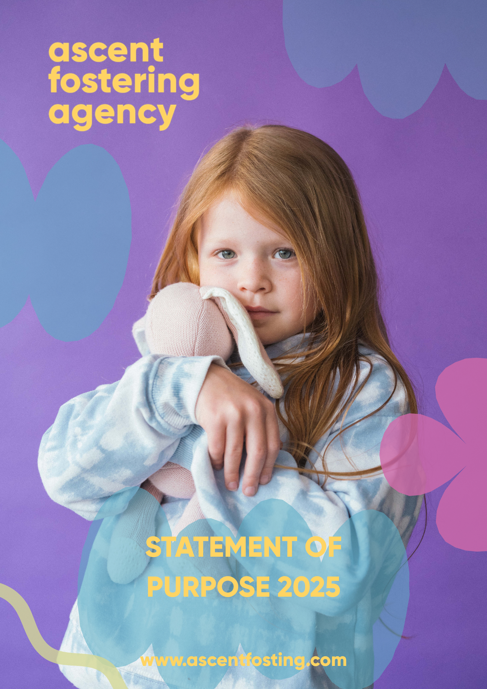
A Therapeutic Fostering Agency
INTRODUCTION

This document sets out the Statement of Purpose and function of the Ascent Fostering Agency Ltd (AFA) as an Independent Fostering Agency.

The Ascent Fostering Agency Statement of Purpose provides a range of information that is intended for a broad audience:

- Looked After Children (LAC)
- Parents of Children
- Foster carers and prospective foster carers
- Ascent Fostering Staff
- Local authorities, health and social care trusts who place children or are considering placing them with the agency
- Ofsted
- General public

The Ascent Fostering Agency Statement of Purpose meets the following:

- The Care Standards Act 2000
- The Fostering Services Regulations 2011
- The National Minimum Standards for Fostering 2011
- The Children's Act 1989
- Human Rights Act 1998
- Data Protection Act 1998

The Ascent Fostering Agency Management Team will review the Statement of Purpose regularly or annually.

Ascent received an Outstanding for the second time in a row from Ofsted in October 2024 and Platinum with Investors in People (InP).

VALUES

Ascent Fostering Agency believes its core values set it apart from many other providers; our values are:

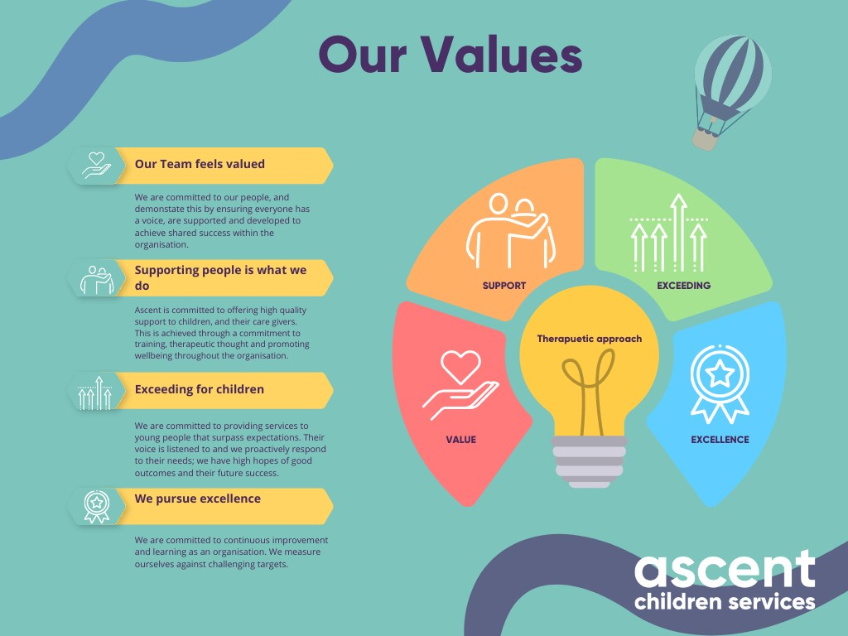

- WE GO OVER & ABOVE IN OUR PROVISION FOR YOUNG PEOPLE
- OUR TEAM FEEL VALUED AND ARE DEVELOPING THEIR SKILLS
- SUPPORTING OUR CARERS IS AT THE HEART OF THE ORGANISATION
- WE PURSUE A CULTURE OF EXCELLENCE IN ALL WE DO

Ascent Fostering Agency challenges itself to live its values through engagement with young people, foster carers, and staff. We reaffirm this with our commitment to supporting young people to recover from the impact of trauma.

AIMS & OBJECTIVES

Ascent Fostering Agency is an Independent Fostering Agency with a therapeutic approach to support children and young people who require foster care. The agency works with children and young people with complex care needs and offers bespoke care and support packages within a family setting. We achieve this by supporting families who care for young people creatively.

Our approach to foster care support is called 'Intentional Parenting.' This encapsulates all our interventions and methods to support and engage with young people with high care needs. Our approach ensures the whole professional team at Ascent has a therapeutic understanding, including support staff. Practically, this means we are not wedded to any fixed point of view about placement support and have explored many approaches that impact children the most. We are committed to building a strong relationship with young people and accepting where they are when coming to Ascent. This approach to seeing the world from a young person's perspective informs us how we engage and go on the journey with them.

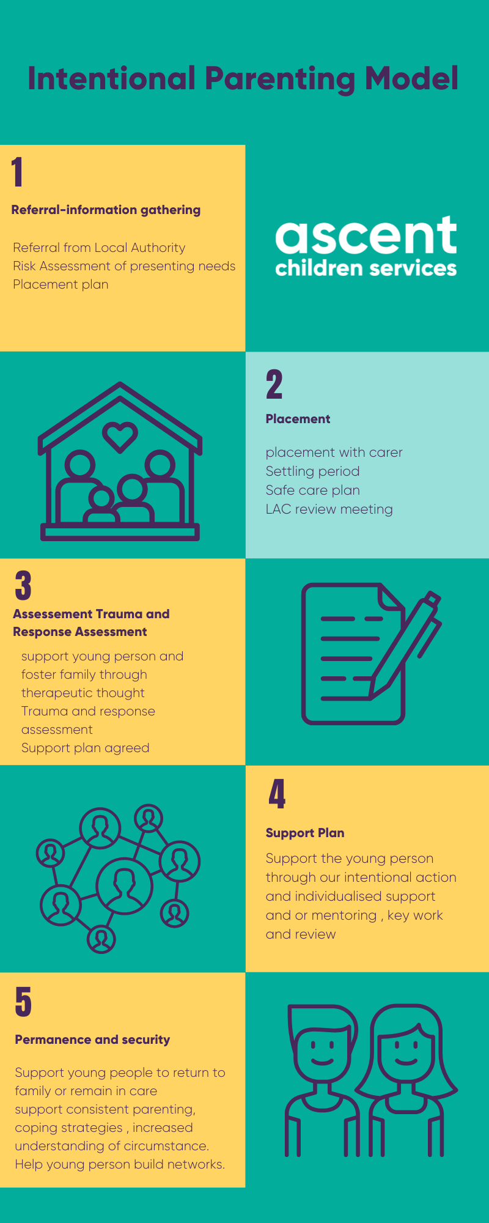
The agency supports staff and foster carers' personal development. We have trained all workers in DDP (Dyadic Developmental Psychotherapy). All Supervising Social Workers (SSW), Therapeutic Consultants, managers and mentors are DDP trained in Level One, with the SSW team completing Level Two. The agency also delivers DDP's 'Nurturing Attachments' training for foster carers who have completed the level 1 and 2 therapeutic parenting courses. Nurturing Attachments is an intensive 12-week course which explores the attitude of PACE (Playfulness, Acceptance, Curiosity and Empathy). Foster carers can also access training with the National Association of Therapeutic Parents (NATP) and Beacon House. Our ethos is to meet children at their 'map of the world'. Our foster carers intentionally parent children on their journey to recovery from their early life experiences through intensive support and mentoring. We aim to build relationships with young people that are safe and supportive.

We engage with young people in many ways, including mentoring and personal development, which supports young people through mentoring and accessing creative arts, sports, and music.

Intentional Parenting
Intentional Parenting is our model of how we support our children. We believe the onus is on adults to respond to the unmet needs of children positively. It is challenging to care for children who have experienced trauma, so the network needs to be trained, attuned, and supported to see past the child's presenting behaviours.
We believe that carers and professionals need to act intentionally in our interactions with vulnerable children by providing nurture, affirmation, love, safety, structure, and challenge. These interactions are attempts to meet the deficits of their previous parental experiences, but, most importantly, give them strategies to cope and move on positively with their lives.

We believe that no one theory meets the needs of human beings, so we have drawn upon and work within existing theoretical approaches such as attachment, systemic theory, and psychodynamic approaches. We recognise the need to remain open and curious about methods or ideas in aiding us to respond to each child's needs.
‘I just wanted to jot down in a few lines how amazing J and N are as carers.
They took on three very difficult children, with a very difficult birth mother, and they weathered
the storms for longer than anyone would have thought possible!’ Head Teacher John Stainer School

What is our Ascent Trauma and Response Assessment?
Ascent’s Trauma and Response Assessment (TARA) has been devised to understand a child's story and their experience of trauma and loss. We believe that exploring children's past, present and predicted future outcomes gives us the best indicators for understanding their unmet needs. With this understanding, we can devise a therapeutic plan, an appropriate intervention, and, importantly, support for the foster carer to support the young person in a placement best suited to move forward.

What does this look like for children and young people?
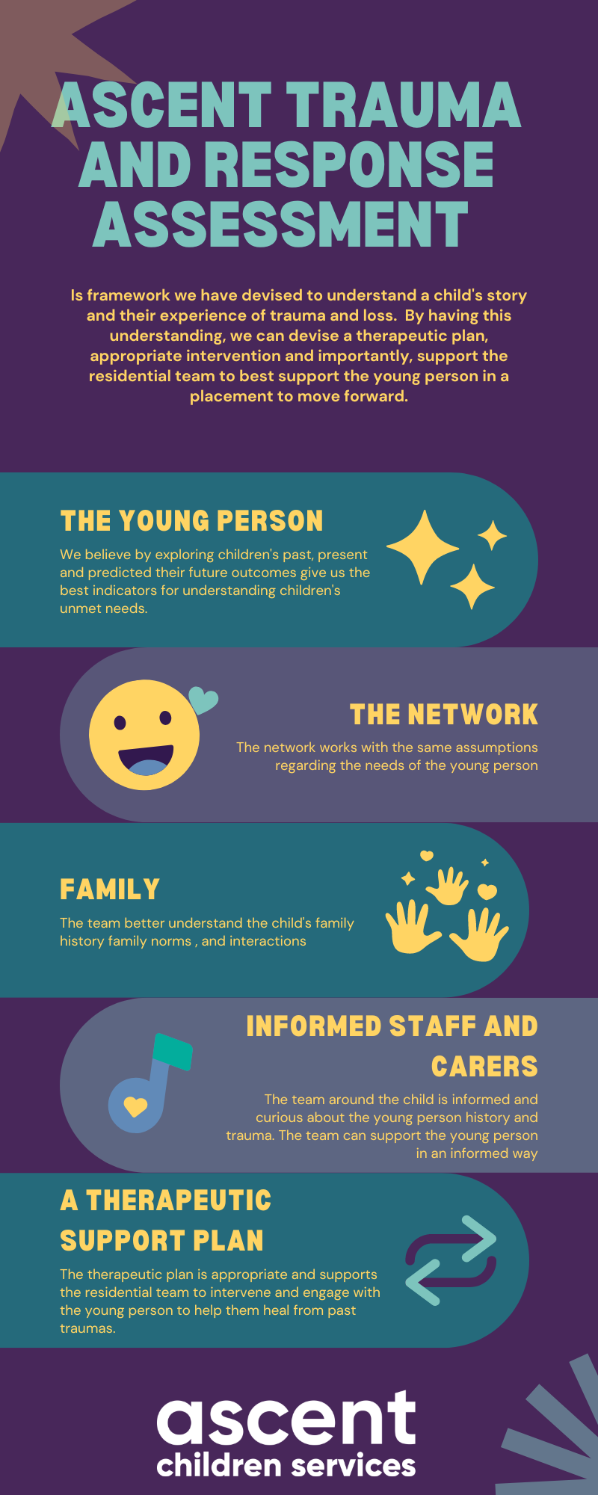
In real terms, we provide foster carers with a genuine understanding of the young person's experience, not just words in a referral and challenging behaviour. The team (foster carers, SSW, Therapeutic Consultant, mentor, and child's social worker) reflects on the young person's experiences before entering care, and we try to understand the impact and the hurt of this experience. We expect that foster carers' care will provide warmth and safety and will journey with the young person while they test boundaries, revisit trauma, and challenge us to prove we care. The task of the foster carer is to build trust, security, and safety through an attitude of PACE (Playfulness, Acceptance, Curiosity and Empathy) in their response, as most of this work takes place in their home and family. The foster carer will be supported via our therapeutic team to address some of the issues impacting the young person and their household.
We offer young people therapeutic mentoring sessions which may explore specific areas, i.e., problem-solving, keeping themselves safe, regulating their emotions, conflict management and getting involved in groups or clubs. The young person can also access more structured therapeutic intervention to help them process trauma through one of the agency’s internal or commissioned therapists. This work involves supporting the children and foster families who live with the child.
Our SSWs ensure that the support plan and outcome for children and young people are enacted and liaise with local authority partners.

Ascent Fostering Agency will provide the following:

- High-quality care for children and young people who are looked after in foster care.
- A commitment to supporting each child/young person as an individual with unique needs.
- 24-hour support for foster carers and children/young people
- A community-based service
- A commitment to the recruitment of foster carers from diverse backgrounds
- A consideration of ethnicity, gender, sexuality and disability of fostered children and young people when making placement and matching decisions
- A commitment to the ongoing learning and development of foster carers, to support them in achieving the highest standards of care.
- A commitment to developing the skills to meet the most complex needs of children and young people.
- A commitment to the ongoing development of staff
- Placements that are safe, nurturing, and protective, where children and young people are treated with respect and dignity.
- Children and young people will be encouraged, nurtured, and supported in a family setting where shared values are upheld, and their individual needs and differences respected.
- A commitment to managing risk proactively.
- An ongoing dialogue with the children and young people we care for, along with carers and the local authority, about how we can improve our services.

STATUS & CONDITIONS

Ascent Fostering Agency is an Independent Fostering Provider (IFP), is a private limited company registered under the Companies Act 1985 (Company Number 08252409).
In accordance with the Companies Acts 1985 and 1989, Ascent Fostering Agency Ltd has produced a Memorandum of Association and Articles of Association. Copies of the Memorandum of Association and Incorporation certificate have been made available to Ofsted, which is the independent, non-governmental regulatory authority for independent fostering agencies throughout England.

MANAGEMENT TEAM

Ascent Fostering has a management team comprising:

Mark Pomell, Managing Director (Responsible Individual)
Mark is a qualified social work manager and has a master’s in management. He has over 30 years of experience in social care. Over the last 20 years, Mark has worked at a senior management level in the statutory and private sectors.

Mark Hobbs, Commercial Director
Mark qualified as a Chartered Accountant with Ernst & Young in 2002; Mark has over a decade of experience in senior financial management, including senior roles at FTSE 100 companies. Mark has also spent over 17 years developing and leading youth work with young people. In 2010, Mark founded a youth charity called Reaching Higher, which has quickly grown into a thriving organisation delivering outstanding results in the community. Mark combines his passion for seeing young people thrive with his management experience to good effect at Ascent Fostering.

Sita Alexander, Fostering Director (Registered Manager)
Sita has a B.A. Honours in Sociology, a Master's in Social Work, and a Diploma Level 5 in Leadership and Management. Sita has worked across several voluntary, statutory, and private settings, including residential care, child protection, looked-after children, education, and prison. Sita has worked for Ascent for over ten years and has been part of the development of the Ascent therapeutic model and the learning and development of staff and foster carers.

Nicky Challen-Probert, Team Manager
Nicky is a qualified social worker and has over 20 years of experience in this field. Nicky worked for 4 years in South Africa as a qualified Social Worker and worked within the social care field as well as with asylum seekers and refugees. Since working in the UK, Nicky has predominantly worked within the fostering field, where she has held various positions, from being a supervising social worker to managing panels and Form F assessors, supervising staff, delivering training, sitting as a panel advisor, supporting social work students, and completing Form Fs. Nicky has completed a Post Qualification in Childcare and holds a Diploma in Therapeutic Life Story Work. Nicky has been with Ascent for over 5 years and has a great passion for working therapeutically with children, families, and the wider network.

The Ascent Fostering Agency Management team is responsible for the following:
- The organisation's vision and mission
- Quality Standards & Management Systems
- Fulfilling statutory duties and responsibilities
- The values to be promoted throughout Ascent Fostering
- The strategic direction and goals of the organisation
- The organisation's policies
- The annual business & development plan
- Major financial expenditure decisions

The organisation has separate documents which detail the qualifications and experience of staff. These documents are available on request.

STAFFING

- Ascent Fostering Agency has a board of 2 Executive Directors, Mark Hobbs and Mark Pomell.
- In post is a Fostering Director who is also the Registered Manager FT, Team Manager FT, Two Senior and Two Supervising Social Workers FT, a team co-ordinator FT, two administrators FT, a Placement support worker PT, Head of Youth Engagement and Independence FT, three Therapeutic Consultants FT and PT, a Finance Manager PT, and an accounts and HR assistant PT.
- Additionally, Ascent contracts therapeutic support for their children and young people from a sessional support team, which consists of an Occupational Therapist, Art Psychotherapist, Play Therapists, Counsellors, Educational Psychologist and Clinical Psychologist as required.
- Additional independent assessment and reviewing officer support.
- Qualified sessional social workers are commissioned to undertake Coram BAAF Form F assessments and present them to the panel. Formal qualifications and CVs of all sessional social workers are available on request.

Concerning all staff, we expect:
- Supervising Social Workers are qualified and registered with Social Work England, and the Therapeutic Consultants are registered with relevant professional bodies.
- The agency has appropriate insurance; staff have job descriptions, contracts of employment, and annual appraisals and are appropriately DBS checked.
- Managers and staff members receive supervision and appraisal in accordance with their roles and responsibilities.

Role and Responsibilities

Senior Leadership Team (SLT)
The SLT comprises of the Managing Directors, Fostering Director, and Team Manager, who meet monthly to monitor compliance and outcomes for children and families. Feedback is then provided in the practice meetings and group supervision.
The Team Manager is responsible for the supervision and management of SSWs. In Ascent Fostering, the Fostering Director and Team Manager are responsible for the day-to-day function of the organisation. Quality Assurance is an integral part of their roles as part of ensuring that Ascent is compliant and has effective monitoring trackers.

Supervising Social Workers (SSWs)
The SSWs have responsibility for the assessment, support, supervision, and annual review of foster carers. Also, they work in close partnership with the Looked After Children's Social Worker. They will attend Looked After Reviews and Personal Education Plan (PEP) meetings with the foster carer to ensure the best outcomes for children placed with our carers. SSWs are responsible for monitoring foster carers' continuous professional development and training. They ensure that all foster carers complete the Training, Support and Development Standards (TSDs) and maintain an ongoing portfolio. Also, SSWs coordinate and deliver support groups for foster carers and provide the frontline delivery of Out of out-of-hours services to carers.

Ascent SSWs are DDP (Dyadic Developmental Practice) trained and engaged in Sensory Attachment Intervention (SAI), Non-Violent Resistance (NVR) and Theraplay training. Furthermore, Ascent has a therapeutic programme that all workers complete. Our commitment to this level of professional training means we can offer therapeutic solutions and strategies to children with the most complex needs.

Therapeutic Support Team
At Ascent Fostering, our placement support workers and mentors support placements by engaging with young people and offering mentoring and advocacy to help young people find practical ways of solving the challenges they face in their lives. Input is time-limited, and the solution focuses on enabling those supported to achieve personal growth and development.

Our Therapeutic Consultants provide training, consultation, support, and advice to foster carers and the professional network around the child. They also undertake direct work with children and can provide therapeutic support and consultations to the children’s schools and to birth families where it is deemed safe and appropriate by the local authority.

Fostering Panel
Ascent Fostering has a fostering panel comprising of members with relevant child-care and statutory social work experience. This includes care leavers, Assistant Head Teacher & SEND Lead Coordinator/former Foster Carer, a panel advisor, a Well-being Support Worker For Carers, a Safeguarding Lead from Education/Social Worker, Two care-leavers, Children’s Guardian CAFCASS, social workers, teachers, and a connections worker. The panel chair and minute takers have undertaken Coram/BAAF training.

Ascent Fostering panel and staff members are recruited per "safer recruitment" guidelines. Ascent Fostering must consult the Fostering Panel in considering the approval of foster carers and in drawing up and reviewing fostering arrangements. The panel must consider the following:
- Each application for approval as a foster carer and recommend whether a person is suitable to act as a foster carer.
- Where it recommends approval of an applicant, the terms on which approval is to be given.
- Whether or not to recommend a foster carer's ongoing suitability to continue acting as a foster carer and whether their terms of approval remain appropriate:
- On the first review within 12 months of initial approval,
- On the occasion of any other review when requested to do so by Ascent Fostering
- A foster carer's suitability to continue acting as a foster carer following investigations into allegations of serious concerns about a foster carer's standards of care and making recommendations on further support and training needed in keeping Ascent Fostering's Managing Serious Concerns policy.

The Fostering Panel also advises on the reviewing procedures and monitors this effectiveness. They also oversee the conduct of assessments and make recommendations on such matters or cases as the fostering service may refer to them.
The Ascent Fostering Panel can only make recommendations as the Agency Decision Maker (ADM) makes a formal decision. This process takes seven working days.

It is Ascent Fostering Agency’s policy that:
- All foster carers attend the fostering panel for their approval and the first annual review.
- All foster carers subsequently return for their three-yearly review.

RECRUITING, APPROVING, TRAINING, SUPPORTING AND REVIEWING FOSTER CARERS' ASSESSMENT AND APPROVALS:

Ascent Fostering assesses the suitability of individuals or families to foster; we seek people who have a good enough understanding of children in the care system. They must demonstrate a willingness to learn and develop new skills if they wish to foster for Ascent.

In general, the assessment process takes up to 4 months. The steps to foster with Ascent are:
- Initial enquiry - On receiving an enquiry from a potential foster carer(s), Ascent Fostering requests basic information to ensure that the enquirer can fulfil the organisation's requirements to provide safe and nurturing families. Ascent Fostering literature and an application pack are sent to the enquirer if satisfied.
- Initial assessment - the management team will consider the information and arrange an initial visit if appropriate. The initial visit assessment is presented to the team manager, and a decision is made on whether to proceed.
- Application to Foster is Stage 1. The potential foster carer(s) complete(s) an application form, giving detailed information about themselves and their family, and give consent for Ascent Fostering to complete necessary checks and enquiries to ascertain their suitability to foster. Stage 2 is the full Assessment. If the decision is made to proceed, a qualified social worker carries out a Form F1 assessment. They will visit the applicant s) home, on 6-8 occasions, to meet and collect information about all household members and the applicant's experience and skills concerning fostering.
- Preparation training (Skills to Foster) is provided, which covers the responsibilities of being a foster carer and working with Ascent Fostering. All prospective foster carers must attend this training before their approval.
- Statutory checks form part of the assessment (Stage 1/2) and include:

    - Disclosure and Barring Checks are completed on all adult members of the family and all regular visitors to the household. These involve the disclosure of information about any criminal convictions or cautions and other information which may be held by the Police or Government agencies relevant to the protection of children.
    - Enquiries to: Social Services Departments and their Child Protection Registers.
    - Other agencies, e.g., Schools and Employer (where appropriate)
    - Medical - The applicant(s) is/are required to have a medical examination completed by their G.P. The report is made available to Ascent Fostering's Medical Adviser for recommendation about the applicant(s) health and any impact on fostering potential.
    - Personal and relevant work references

- All information obtained on prospective foster carers is held on file. References from external agencies (Police, Ofsted, Social Services, Medical) and personal references cannot be accessed without the consent of the subject and relevant referee(s).

- Assessment report - The information obtained forms the basis of an assessment report. Ascent Fostering uses the Form F1 format published by the British Association for Adoption and Fostering (BAAF). The content of the Form F assessment report is shared with the applicant(s).

- Fostering Panel - The report is presented to the Fostering Panel. The panel makes recommendations about the suitability of applicant(s) to be approved as a) foster carer(s) with Ascent Fostering Agency. To assist in the decision-making process, applicants must attend the Fostering Panel.

- Approval decision - The ADM receives the recommendation of the Fostering Panel and, on behalf of the agency, makes the final decision about approval/appointment. Applicants are informed verbally and in writing about the organisation's decision.

SUPPORT

Ascent Fostering Agency values the work foster carers do and their contribution to the lives of the children and young people they look after. Support for families who foster is vital to successful outcomes for children. We ensure our families receive additional help and support through training, access to a mentor, and therapeutic advice.

We recognise that fostering is stressful, so providing a flexible and responsive support service to our foster carers is vital. Arranging an Ascent Trauma and Response Assessment and devising a support plan when children are 'matched' reassures families when they care for children with complex needs. Ascent Fostering offers the following support and services to all our foster carers, children, and young people.

Social work and therapeutic support:
- 24-hour support
- Supervision and support from a Supervising Social Worker (SSW)
- A comprehensive training programme
- A Therapeutic Consultant who will offer monthly consultations
- A minimum of weekly contact and monthly visits by an SSW
- Therapeutic parenting training levels 1 & 2
- Nurturing Attachments training
- Consultation groups
- Monthly meetings with other foster carers for mutual peer support and friendship
- Membership to the Foster Talk and Coram/BAAF
- Consultation groups chaired by Therapeutic Consultants
- An annual programme of activities involving all the foster families.

Therapeutic support
Ascent Fostering uses a therapeutic model to support foster carers, and this includes actively training foster carers to understand the 'inner working model' of children through an attitude of PACE (Playfulness, Acceptance, Curiosity and Empathy).
When we use the term therapeutic, we mean a 'specialised' service for foster families: it is a way of caring for children that supports them in healing, and the carer goes alongside them on their journey. We achieve this by offering planned therapeutic help and support over some time.

The work focuses on recognising and acknowledging the unmet needs of the child or young person and understanding and addressing the impact of traumatic early experiences on children (for example, serious loss, neglect, abuse, or extreme attachment difficulties). Such experiences are likely to have had severe consequences on the child's capacity to be parented or cared for, make friends, trust, or be part of the group, learn and be taught, and respond appropriately to everyday life experiences. These difficulties are unlikely to improve without intensive and skilled therapeutic support on a 24-hour-a-day basis.

At Ascent Fostering, we provide therapeutic support for foster carers in several ways. This is to help them understand the complexities and equip them with skills and techniques for working with children and young people who have experienced trauma. We also provide an extensive training programme which includes two four-day training courses in therapeutic care and support for children.

Additionally, we provide weekly therapeutic support for those young people who have attachment difficulties and have experienced trauma in their early years. While some young people may have access to CAMHS, we find that many are often reluctant to engage for fear of being labelled or misunderstood. Our Therapeutic Consultants and sessional Therapists will meet young people at their map of the world. By this, we mean that young people will decide how and where they want to engage.

Financial Support:
- A competitive level of financial support that values the skills of foster carer(s) and meets the overall needs of the child/young person placed.
- Three weeks of paid respite per year.
- Holiday Allowance for the children and young people in the foster home.

Support services available to children and young people:
- In association with a children's charity, children and young people within the Ascent network can access a range of supports, clubs and residential camps, including:
- Personal mentoring,
- Weekly Clubs including football academy, creative arts – dance, drama, music, and filmmaking,
- Physical, Social, Health & Education (PSHE) workshops on bullying, managing conflict, budgeting, and leadership skills,
- Support with regards to CSE, CCE, radicalisation, healthy and unhealthy relationships, consent, health
- Therapy & Counselling,
- Annual leisure activities, including outings and trips.

These services ensure that foster carers are fully supported and that young people's placement outcomes are successful. We expect people who foster for Ascent to be resilient and open to their learning and development.

TRAINING

We recognise that fostering has become increasingly more demanding, complex, and diverse. Ascent Fostering is committed to providing high-quality training and mentoring for carers.

The delivery of and attendance at training is inherent to good quality childcare and is an essential element of our support to foster carers. It assists in the agency's ability to support good outcomes for children.

Attendance at training encourages foster carers to take responsibility for their professional development and learning. Ascent Fostering is committed to supporting foster carers to receive formal qualifications and will support carers to achieve them where possible. All carers will complete the TSD standards for foster carers within the first 12 months of approval.

The overriding objective of our training programme is to support carers to develop specialist and therapeutic knowledge and skills that cater for the needs of the most vulnerable children and young people with high-end complex needs and challenging behaviours.

Ascent's foster carers have the opportunity to:
- Complete therapeutic training,
- Develop their understanding of their role and responsibilities, improve their knowledge, and develop and refine their skills as substitute parents,
- Raise their awareness of the psycho-social backgrounds, resulting in vulnerabilities, and therapeutic needs of looked-after children/ young people,
- Encourage foster carers to reflect and understand the effects of discrimination in all forms and parts of the community,
- Ensure that all foster carers are competent and confident in safe caring and safeguarding children.

The Training Programme is created to address the learning needs of all carers at every stage of their fostering career. The training programme has four stages, which include:

- Preparation and Induction training for applicants in assessment
- All Foundation training is mandatory for newly approved carers in the first year of approval.
- Core training is for all foster carers on various developmental and general fostering issues and is available to all carers.
- Specialist training for more experienced carers.

The Foundation training programme for newly approved carers consists of:
- Therapeutic Parenting Courses
- TSD workshops
- First Aid
- Working Together to Safeguard Children
- Managing Allegations and Safer Care
- Recording and Record-Keeping

Core Training is for all foster carers (this is accessible online and face to face), some examples are:
- Equality and Diversity
- Management and Administration of Medication
- Manage Behaviour and Promote Positive Relationships
- Life story work training
- Training on Autism and ADHD
- Child Sexual Exploitation

Specialist Training can also be accessed by all foster carers, some examples are:
- Therapeutic parenting courses
- Nurturing Attachments training (12-week course)
- The Just Right State Programme
- Theraplay
- Therapeutic Workshops
- Non-Violent Resistance Training (NVR)

INSURANCE

Ascent Fostering has the appropriate insurance, which includes the following:
- Employer's liability up to £10,000,000
- Public liability up to £10,000,000
- Business contents/interruption

Each fostering household is expected to have appropriate household insurance and, if they drive, have fully comprehensive insurance on vehicles used to transport young people.

MEMBERSHIPS

Ascent Fostering Agency is a full member of Coram/BAAF. All foster carers will have full membership with Foster Talk, which includes legal cover.

REVIEWING

At Ascent Fostering Agency, we have a procedure for completing foster carers' annual reviews. This procedure reflects the legislation, regulations, National Minimum Standards 2011, and good practice. Annual reviews are chaired by independent professionals who offer the agency feedback.

In addition to the requirements to conduct annual reviews, Ascent Fostering Agency will bring forward annual reviews in the event of significant changes in the foster household or other serious events, i.e. following a serious complaint or incident. In the process of conducting carers' reviews:

- Looked-after-children, birth children's and household members' views of the foster home are sought.
- We seek professional feedback from the looked-after child's social worker and the child’s IRO.
- An appraisal of the carer's training and development needs is undertaken.
- Following a recommendation from the fostering panel, the ADM makes the final decision on the carer's ongoing suitability to foster.

It is the agency's policy:
- All foster carers are reviewed annually by the agency's designated Independent Reviewing Officers (IRO).
- All the foster carers' annual reviews are presented to the fostering panel.
- All foster carers attend the panel for their first and third annual reviews, then every three years after that or if their approval terms change.

SERVICE PROVISION

Our placement options cover all eventualities from emergency to long-term fostering.

Placement Types:
• Short Term
• Long-term
• Emergency
• Assessment
• Bridging
• Respite & Holiday
• Parent & Child
• Solo placement
• Teenage specialist placements
• Transition into independence
• Sibling Groups
- Step-down placements from residential

Ascent Fostering Agency is also linked with the other part of the organisation, which is Ascent Family Homes. The first home is called Aspen House, which is a five-bedroom residential provision for males aged 11-15. The second home is Eden House, which is a five-bedroom residential provision for females aged 9-15. This offers stakeholders a step-up, step-down provision for children who may need to spend a period of time in residential care before they are supported to be transitioned to a foster family, a semi-independence provision or returning to their birth families. Ascent Family Homes holds the same values and therapeutic vision for children and young people in its care.

PLACEMENT REGULATION

All placements of children and young people with Ascent foster carers are made and monitored per the Fostering Services Regulations 2011 and meet the National Minimum Standards. This means that:

- All foster carers are appropriately approved, reviewed, and have signed a Foster Care Agreement.
- All children's placements are made using individual foster placement agreements,
- Matching meetings and pre-placement planning are undertaken, and where possible, this includes children having introductions to the foster carers.

CONSULTATION

Children and young people's views are sought through our annual consultation survey and as part of foster carers' annual reviews. All feedback forms are reviewed by the Team Manager and tracked using a spreadsheet to ensure prompt follow-up on any concerns or issues reported by children.
Most of our children enjoy their placements and engage with therapeutic and mentoring teams.
We have also organised a Young Council, which is facilitated by our Placement Support Worker and Head of Youth Engagement and Independence, to enable young people to have a say and influence the organisation.

COMPLAINTS

The Ascent Fostering Agency's complaints procedure emphasises resolving complaints at a local level:

Stage 1
- Informal problem-solving by the SSW and line manager
- Records of investigations and outcomes of complaints resolved informally are held on file for inspection by Ofsted and/or other regulatory bodies.
- All children/young people placed with Ascent foster carers are informed of the organisation's complaints procedure via a Children's/Young People's Guide.
- All foster carers, staff and children's/young people's placing authorities are given information about Ascent Fostering's complaints procedures.

Stage 2
- Complaints are those where resolution at Stage 1 has not been possible, or a complainant has elected to invoke Stage 2 of the procedure directly. Complaints of this nature are dealt with by the Team Manager or Directors, and if appropriate, independent consultants are appointed to carry out formal investigations.
Stage 3
- The Ascent Fostering's Representations and Complaints procedure has scope for a complainant, if dissatisfied with the response in Stage 2, to request that the matter be referred to the Services Provider.

ACTUAL COMPLAINTS & OUTCOMES:

Details of future complaints and outcomes will be filed confidentially and made available to Ofsted.

Ascent Fostering Agency is committed to providing excellent care for children. If you have any questions about Ascent or would like to know more, please contact us at hello@ascentfostering.com

